**1.0 Current source and current sinks**

A current source, unlike DC voltage source, is not a physical reality. But it is useful in deriving equivalent circuit models of the semiconductor devices like a transistor. It can also be subdivided into ideal and non-ideal categories.

**1.1 Ideal Current Source:**

The ideal current source sets the value of current running through it.

* Constant dc source; e.g. A
* Time-varying current source: e.g.
* The ideal current source has known current, but unknown voltage.
* The voltage across the current source is defined by the rest of the circuit to which the source is attached.
* Voltage cannot be determined by the value of the current.
* Do not assume that the voltage is zero.

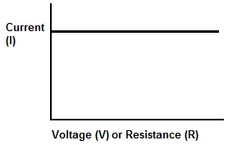

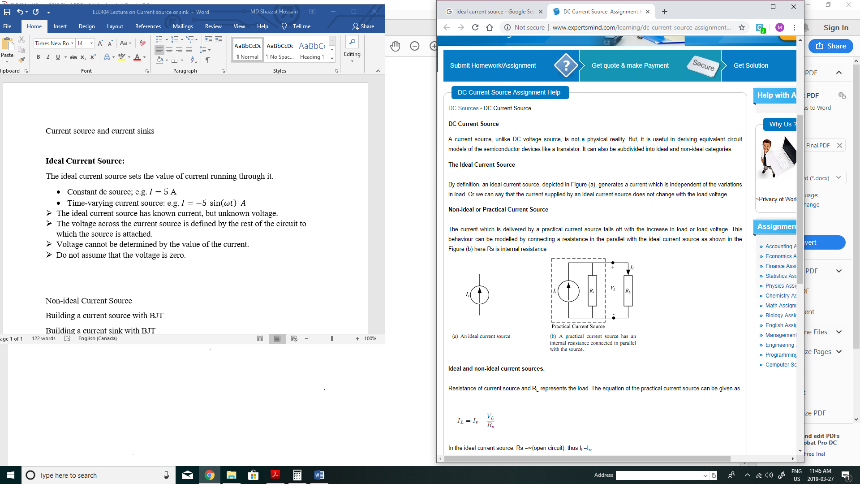

**1.2 Non-ideal Current Source**

The current which is delivered by a practical (non-ideal) current source falls off with the increase in load or load voltage. This behaviour can be modelled by connecting a resistance in the parallel with the ideal current source as shown in the figure here is the output resistance, internal resistance, or Norton resistance.  
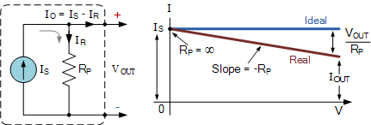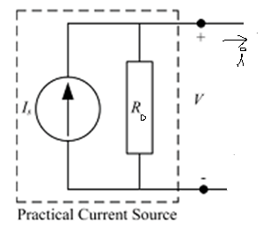

By KCL, we have

It is therefore understood that the larger , the closer to and, therefore, the closer the current source to the ideal current source. A very important interpretation of is that its reciprocal, , is the change in the current for every unit of voltage change.

**Example#1**

A current source has an output resistance of 100kΩ. How much its current change if the voltage across it is changed by ±5V?

Solution:

Thus, if , then

**1.3 Building Current Sources and Current Sinks with BJT**

Consider a BJT in the active mode but ignore, for now, the Early effect:

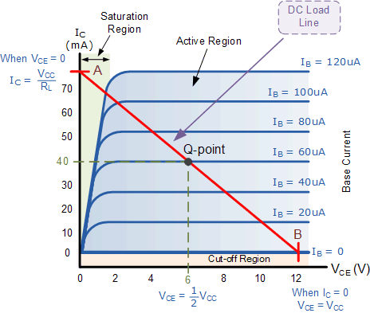

given

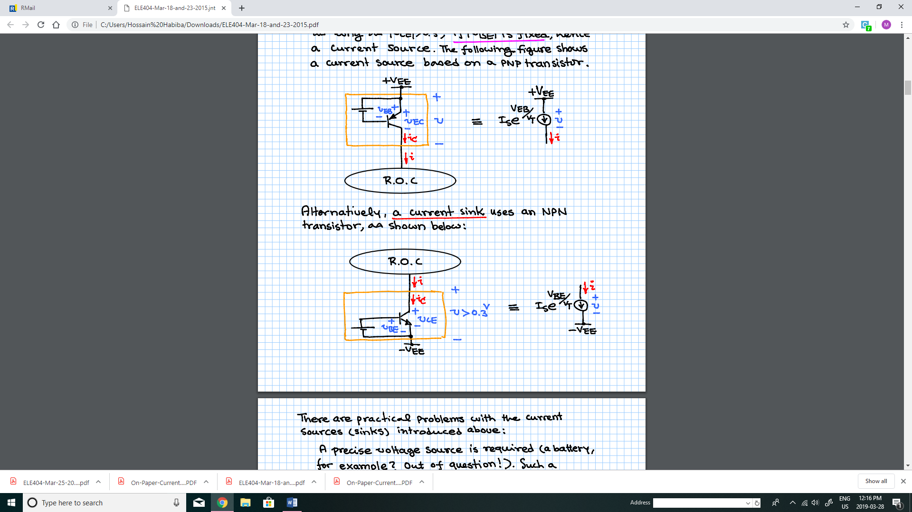Thus, will be fixed, irrespective of as long as ; if is fixed, hence a current source. The following figure shows a current source based on a PNP transistor.

Alternatively, a current sink uses an NPN transistor, as shown below:



**1.4 Building Current sources and Current Sinks with MOSFET:**

MOS transistors may be used to build current sources or current sinks.

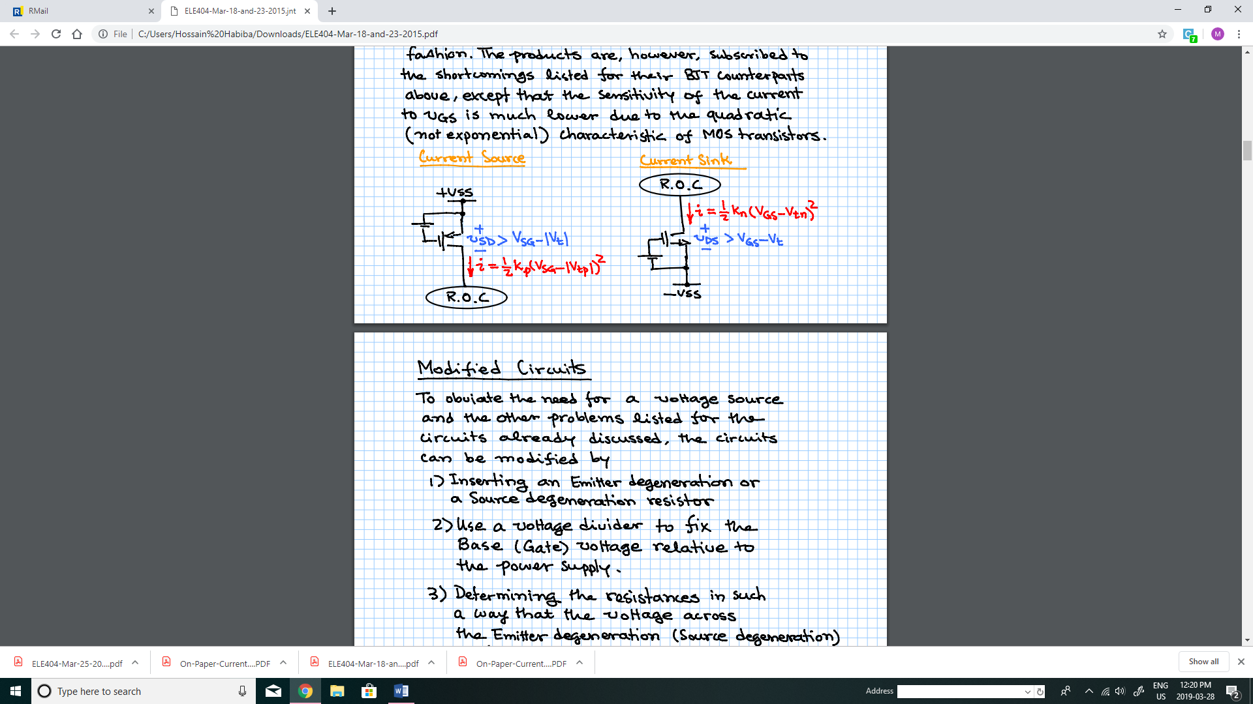

**1.5 Practical Problems with current sources (sinks):**

**1.5.1 Circuits using BJTs:**

A precise voltage source is required. Such a voltage source will have a voltage of about 0.7V (imposed by of the BJT). But to ensure a precise current, the voltage must be carefully tuned (burdensome!). Even if was possible to precisely tuned for a desired current, the current will be very sensitive to temperature due to the temperature dependence of and .

**1.5.2 Circuits using MOSFETs:**

The products are, however, subscribed to the shortcomings listed for their BJT counterparts above, except that the sensitivity of current to is much lower due to the quadratic (not exponential) characteristic of MOS transistors.

**1.6 Factors affecting the Current Sources or Current Sinks Performances**

* The voltage or
* The Sensitivity to the Power supply voltage
* The internal resistance or non-ideality

**1.6.1 Modified Circuits:**

To obviate the need for a voltage source and the other problems:

1. 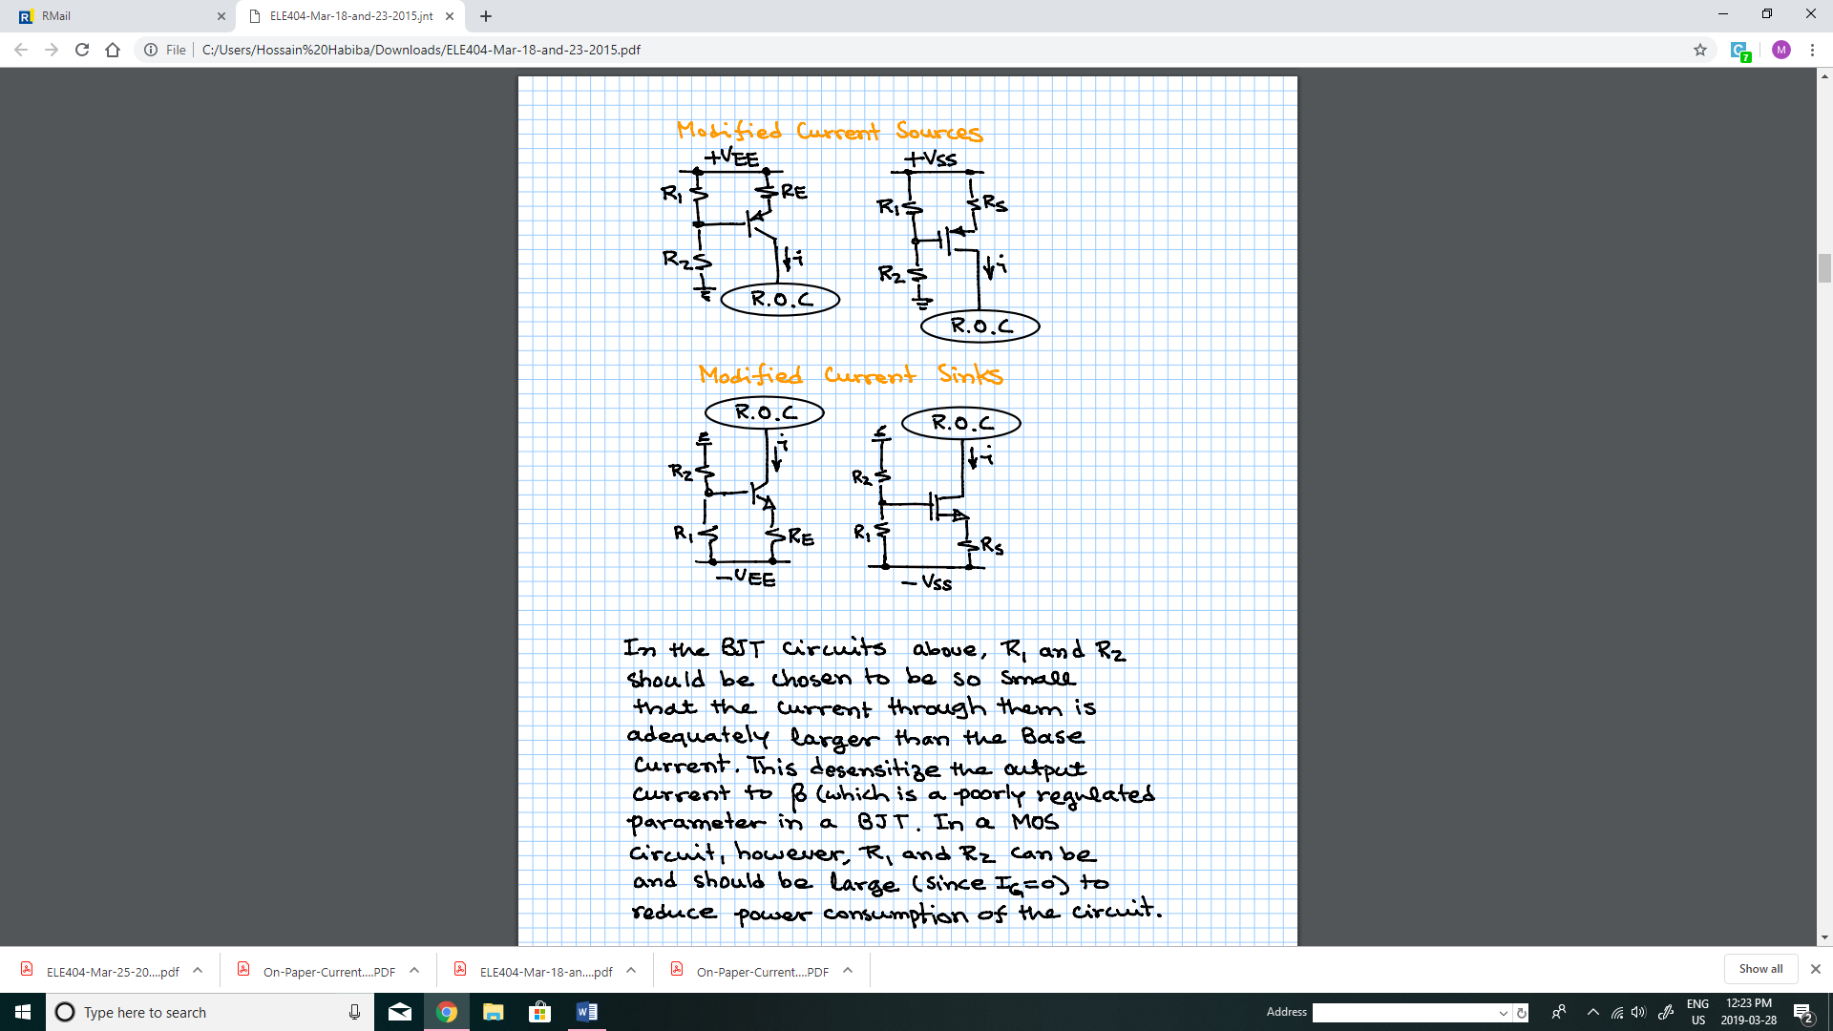Inserting an Emitter degeneration (or source degeneration) resistor
2. Use a voltage divider to fix the Base (or Gate) voltage relative to the power supply.
3. Determining the resistance in such a way that the voltage across the Emitter degeneration (Source degeneration) resistance is a few times larger than () . This will render the current dependent almost entirely on the Emitter degeneration (Source degeneration) resistance, and almost independent of .

**1.6.2 Sensitivity to Power Supply Voltage Variations**

A major shortcoming of the current sources and sinks discussed so far is their sensitivity to the power supply voltage. The sensitivity is due to the following facts:

1. The current is proportional to and determined by the voltage across the degeneration resistance;
2. The voltage across the generation resistance is the same as the voltage across by a difference of or .
3. and, especially, change little with the current, due to the quadratic or exponential characteristic of the transistor.
4. Therefore, variations of the voltage across transfer, very strongly, to the voltage across the degeneration resistance.
5. The voltage across is proportional to the power supply voltage.

Therefore, stability of the current depends heavily on the stability of the voltage across . The best way to enhance the regulation of the mentioned voltage is to replace with either a Zener diode or a chain of diodes.

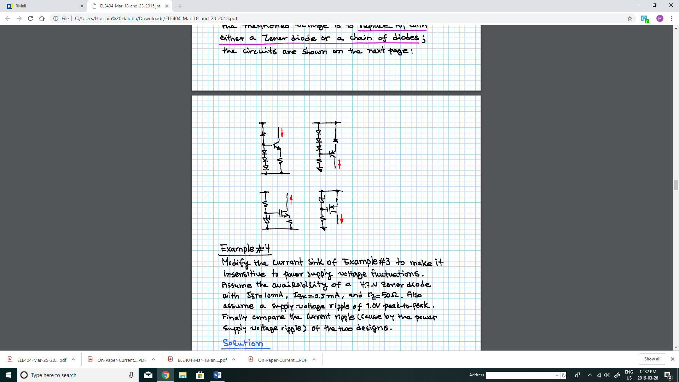

**1.6.3 Non-ideality of the Current Sources and Current Sinks:**

**Inclusion of Early Effect in computing the Output Resistance:**

A real (non-ideal) current source can be modeled as following:

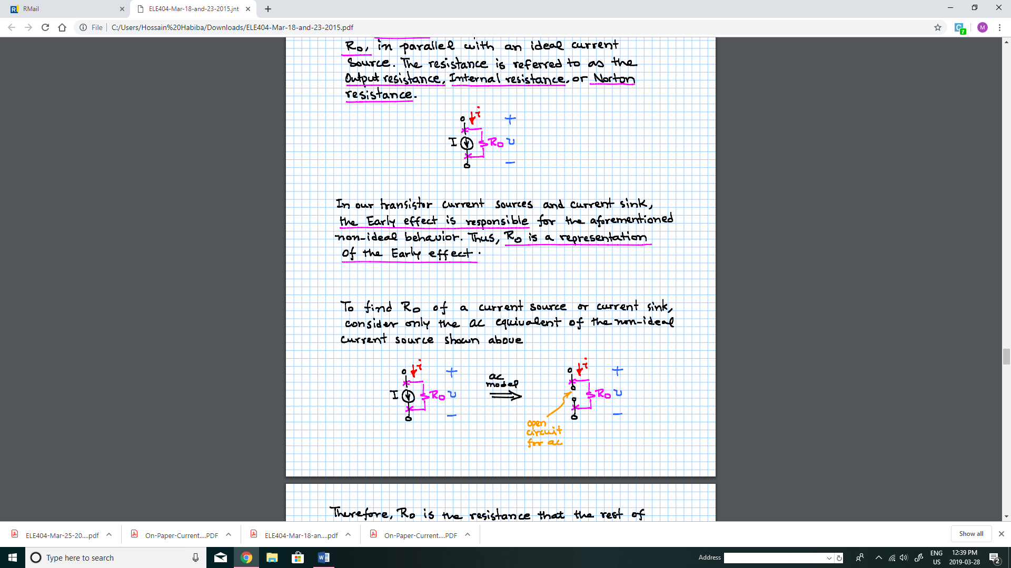

The Early effect is responsible for the non-deal behavior. Thus, Ro is a representation of the Early effect.

To find Ro of a current source (or sink) consider only the ac equivalent of the non-ideal current source.



Ro can be determined by applying a test current/voltage signal to the terminals of a current source:

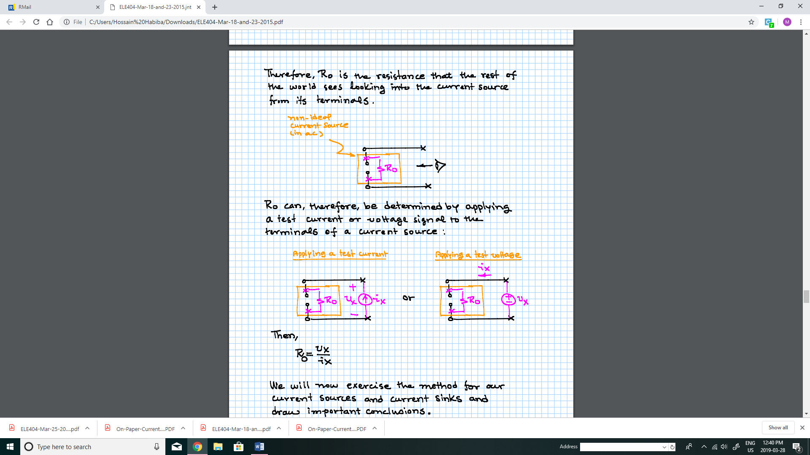

***1.6.3.1 Output Resistance of a BJT current Sink (or source)***

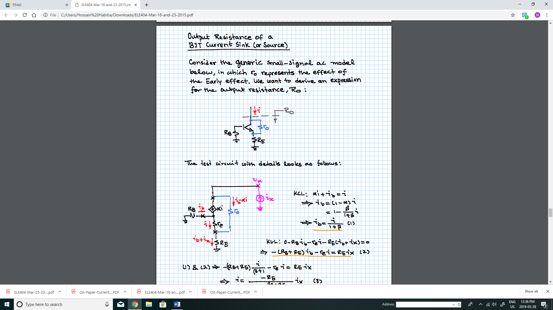

Consider the generic small-signal ac model

KCL:

KVL:

Using (1) and (2),

KVL:

Using (4) and (1),

Using (5) and (3),

Since there is no difference between an NPN and a PNP transistor circuit, the expression above applies to both BJT current sources and current sinks.

If , we can ignore

If a further simplification yields,

The following conclusions may be drawn:

1. i.e. the smallest, if no emitter degeneration. Therefore, enhances the performance of a current source or a current sink.
2. has a detrimental effect as it reduces . Thus, should be kept small,
3. If then , that is Emitter degeneration enhances the output resistance by a factor of .
4. If then , that is the largest possible .
5. If neither nor dominated the others, then (8) must be used for calculating .

**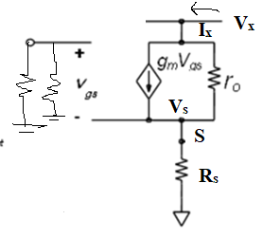*1.6.3.2 Output Resistance of a MOS Current Sink (or source)***

;

**1.7 Current source parameters:**

* Current Value and Circuit Parameters
* Allowable Voltage Range or ‘compliance’
* Sensitivity to Power Supply Voltage variation
* Output resistance (including the Early Effect)

**Example #2**

Design a 0.5-mA current source that uses a BJT with parameters , and . Assume the availability of a single power supply of +10V. Also, determine the range of collector voltage over which the power supply functions properly (this range is also known as the ‘compliance’).

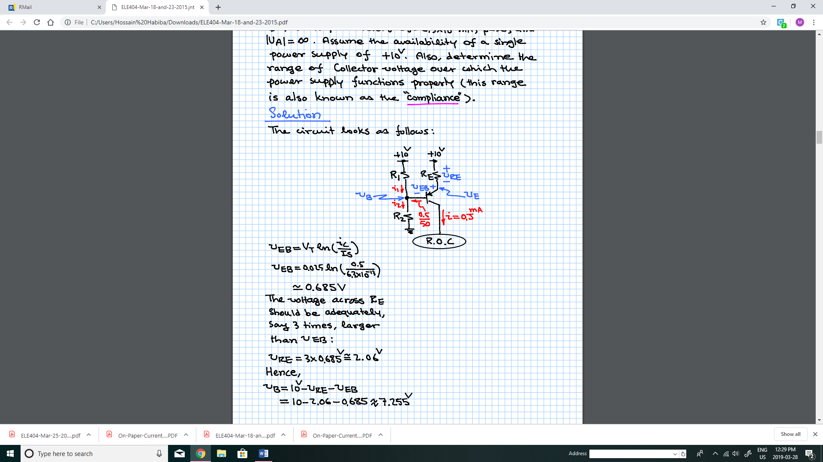

**Solution:**

The circuit looks as follows:

The voltage across should be adequately, say 3 times, larger than :

Hence,

Ignoring , one finds

Then let

Also,

Hence,

The collector voltage range can be calculated as follows:

That is, the current source maintains a constant current of 0.5 mA so long as the collector voltage, which depends on the rest of the circuit (R.O.C), remains below 7.64V.

**Example#3**

Design a 0.7-mA current sink using a MOSFET with the parameters , and . Assume the availability of a single +10V power supply.

1. Determine the permissible range of the Drain voltage. Ignore the channel-length modulation effect (or Early effect).
2. Calculate the current ripple with assuming a supply voltage ripple of 1.0V peak-to-peak.
3. Find the output resistance.
4. Redesign the circuit replacing the resistance with a Zener diode of voltage 4.7V having and . Also calculate the current ripple with assuming a supply voltage ripple of 1.0V peak-to-peak.

